A

Major Project Report

On

**CSGI DISCORSO**

**(House Price Predictor)**

Submitted to

**CHHATTISGARH SWAMI VIVEKANAND TECHNICALUNIVERSITY,**

**BHILAI (C.G.), INDIA**

*In partial fulfillment of requirement for the award of degree*

Of

**Bachelor of Technology**

In

Information Technology

By

**Name : Tamradhwaj Sherpa**

**Roll No. : 300303320001**

***Under the Guidance of***

**Mr. Deepak Sharma Sir**



**Department of Computer Science & Engineering**

**Chhatrapati Shivaji Institute of Technology, Durg**

**Shivaji Nagar, Balod Road, Durg (C.G.), 491001**

**Session 2023-2024**

|  |  |  |
| --- | --- | --- |
| **Chapter No.** | **Title** | **Page No.** |
|  | *Declaration From Student* |  |
|  | *Certificate* |  |
|  | *Acknowledgement* |  |
|  | *Certificate by the examiner* |  |
|  | *Abstract* |  |
|  | *List of Abbreviation* |  |
|  | *List of Figure* |  |
|  | **Introduction** | Approx No. Of Pages, 01 - 04 |
|  | **Dataset** | Approx No. Of Pages, 05 - 06 |
|  | **Data Preprocessing** | Approx No. Of Pages, 07 - 09 |
|  | **Exploratory Data Analysis (EDA)** | Approx No. Of Pages, 10 - 14 |
|  | **Feature Engineering** | Approx No. Of Pages, 17 - 19 |
|  | **Modal Selection** | Approx No. Of Pages, 20 - 22 |
|  | **Model Training** | Approx No. Of Pages, 23 - 26 |
|  | **Conclusion** | Approx No. Of Pages, 27 - 29 |
|  | **Future Work** | Approx No. Of Pages, 30 - 31 |

**DECLARATION**

I,Mr./Ms_____________________________________ Hereby declare that this project report is the record of authentic work carried out by me during the period from -----------to ---------and has not been submitted to any other University or Institute for the award of any degree / diploma etc.

Signature

Name of the student

Date

**CERTIFICATE**

This is to certify that the report of the project submitted is an outcome of the project work entitled **“Online Prediction Modal(WEB APP)”** carried out by :

Students Name Roll No. Enrollment No.

Tamradhwaj Sherpa 300303320001 BJ7573

carried out under my guidance and supervision for the award of Degree in Bachelor of Engineering in Information Technology of Chhattisgarh Swami Vivekananda Technical University, Bhilai (C.G.), India.

To the best of my knowledge the report

1. Embodies the work of the candidate him/herself,
2. Has duly been completed,
3. Fulfills the requirement of the Ordinance relating to the BE degree of the University and
4. Is up to the desired standard for the purpose of which is submitted.

(Signature of the Guide)

**Mr. Deepak Sharma Sir IT**

**Department of Information Technology**

**Chhatrapati Shivaji Institute of Technology, Durg**

The project work as mentioned above is hereby being recommended and forwarded for examination and evaluation.

(Signature of Head of the department with seal)

ACKNOWLEDGEMENT

Firstly, I would like to thank **God** for being able to complete this project with success. I would like express my gratitude towards **Mr. Deepak Sharma Sir**, Head & Professor, Department of Information Technology, CSIT, Durg for his valuable guidance and support. It was indeed an invaluable journey for me.

Now, I would like to extend my gratitude to **Mr. Santosh Sharma**, Principal, CSIT, Durg for providing motivation and valuable guidance throughout the development of the project.

I express my sincere gratitude towards **Mr. Ajay Prakash Verma**, Chairman, Chhatrapati Shivaji Institute of Technology, Durg for providing adequate infrastructure to carry out the project and also motivating for research work, which has been an inspiration.

Lastly, I would like to thank my parents and friends who were a constant source of motivation and support.

**CERTIFICATE BY THE EXAMINERS**

[This is to certify that the report of the project work entitled](https://www.slideshare.net/vishal18900/project-reportformat-by-vishal)

**[“HOUSE PRICE PREDICTOR WEB APP”](https://www.slideshare.net/vishal18900/project-reportformat-by-vishal)**

[Submitted by:](https://www.slideshare.net/vishal18900/project-reportformat-by-vishal)

|  |  |  |
| --- | --- | --- |
| [Student Name](https://www.slideshare.net/vishal18900/project-reportformat-by-vishal) | [Roll No.](https://www.slideshare.net/vishal18900/project-reportformat-by-vishal) | [Signature of the Candidate](https://www.slideshare.net/vishal18900/project-reportformat-by-vishal) |
| [Tamradhwaj Sherpa](https://www.slideshare.net/vishal18900/project-reportformat-by-vishal) | [300303320001](https://www.slideshare.net/vishal18900/project-reportformat-by-vishal) |  |

[has been examined by the undersigned as a part of the examination for the award of Bachelor of Technology degree in Information Technology of Chhattisgarh Swami Vivekananda Technical University, Bhilai.](https://www.slideshare.net/vishal18900/project-reportformat-by-vishal)

[Internal Examiner ExternalExaminer](https://www.slideshare.net/vishal18900/project-reportformat-by-vishal)

[Date: Date:](https://www.slideshare.net/vishal18900/project-reportformat-by-vishal)

**ABSTRACT**

The House Price Predictor project aims to develop a proficient machine learning model for accurately estimating property values based on diverse features. Leveraging a comprehensive dataset encompassing key attributes such as square footage, bedroom count, location, and more, the project navigates through crucial stages from data preprocessing to model evaluation. The dataset undergoes meticulous cleaning and preprocessing to ensure data quality, involving the handling of missing values, outlier removal, and feature scaling.

Exploratory Data Analysis (EDA) illuminates valuable insights into feature distributions and relationships, guiding the subsequent feature engineering process. Various machine learning algorithms are considered, and the model is selected based on its ability to generalize effectively.

The training phase optimizes model parameters, while cross-validation ensures robust performance. Evaluation metrics, including Mean Absolute Error (MAE) and Mean Squared Error (MSE), validate the model's predictive prowess. Results demonstrate the model's capability to provide accurate house price predictions, making it a valuable tool for stakeholders in real estate transactions. The conclusion acknowledges the model's success, identifies limitations, and suggests avenues for future improvements, including ethical considerations. The House Price Predictor project contributes to the ongoing advancement of data-driven decision-making in the realm of real estate valuation.

**LIST OF ABBREVIATIONS**

|  |  |  |
| --- | --- | --- |
| **S.No.** | **Abbreviations** | **Full Form** |
| 1 | CSGI | *Chhatrapati Shivaji Institution Group of Institution* |
| 2 | DISCORSO | *Web App* |
| 3 | ES | *Expert system* |
| 4 | TA | *Teacher Assessment* |
| 5 | IT | *Information Technology* |
| 6 | *HTML* | *Hyper Text Markup Language* |
| 7 | *CSS* | *Cascading Style Sheets* |
| 8 | *JS* | *JavaScript* |
| 9 | *Python* | *Python Programming* |
| 10 | *ML* | *Machine Learning* |

**LIST OF FIGURES**

|  |  |  |
| --- | --- | --- |
| **S.No.** | **Figure No.** | **Figures** |
| 01 | *Fig. – 1.1* | Top 5 rows in our data set |
| 02 | *Fig. - 3.1* | Visualization |
| 02 | *Fig.- 4.1* | Show Correlation between Each other |
| 03 | *Fig - 7.1* | Supervised Learning |

**CHAPTER - I**

**INTRODUCTION**

**Introduction**

The real estate industry is dynamic and influenced by a myriad of factors, making the accurate prediction of house prices a challenging yet crucial task. In response to the growing need for reliable property valuation tools, this project introduces a comprehensive House Price Predictor utilizing machine learning techniques. The primary goal is to develop a model that can effectively estimate house prices based on a range of relevant features.

As the project unfolds, the subsequent sections will delve into the methodologies employed, the dataset utilized, the intricacies of model development, and the insights gained from the analysis. Through this exploration, we aim to contribute a valuable tool to the real estate domain, fostering informed decision-making and promoting efficiency in property transactions.

**1.1 Background:**

Real estate transactions involve a complex interplay of variables, including property size, location, amenities, and market trends. Traditional methods of determining house prices often rely on subjective assessments or historical trends, leading to potential inaccuracies. The integration of machine learning aims to address this gap by leveraging the power of data to make predictions with greater precision.

**1.2 Objectives:**

The main objectives of this project are to create a robust machine learning model capable of predicting house prices accurately and to provide a valuable tool for homebuyers, sellers, and real estate professionals. The model seeks to account for various features that significantly contribute to property valuation, offering a data-driven approach to real estate pricing.

**1.3 Significance of the Project:**

Accurate house price prediction is vital for informed decision-making in the real estate market. Homebuyers can benefit from realistic expectations, sellers can set competitive prices, and real estate professionals can make more informed recommendations. The project's significance lies in its potential to enhance transparency, reduce uncertainties, and contribute to the overall efficiency of real estate transactions.

**1.4 Scope of the Project:**

The scope of this project encompasses the development and implementation of a machine learning model using a carefully curated dataset. The model aims to predict house prices based on a range of input features, with a focus on scalability and adaptability to diverse real estate scenarios. The scope also includes exploring various machine learning algorithms and methodologies to optimize predictive accuracy.

**1.5 Structure of the Report:**

This report is organized to provide a comprehensive understanding of the House Price Predictor project. Sections include data collection and preprocessing, exploratory data analysis, feature engineering, model selection and training, evaluation metrics, results, conclusion, and future work. Each section contributes to the overall narrative, elucidating the methodology and findings of the project.

**1.6 Expected Outcomes:**

The successful completion of this project is anticipated to yield a predictive model that demonstrates accuracy and reliability in estimating house prices. The outcomes will be assessed through various evaluation metrics, with a focus on practical applicability and potential integration into real-world scenarios.

**CHAPTER - 2**

**DATASET**

**Dataset of house price predictor project**

Creating an actual dataset for a house price predictor project involves collecting real-world data from various sources. However, for the purpose of illustration, I can provide a simplified example dataset in a tabular format. Please note that this is a synthetic dataset and does not represent actual real estate data.

Here is Top 5 rows in our data set

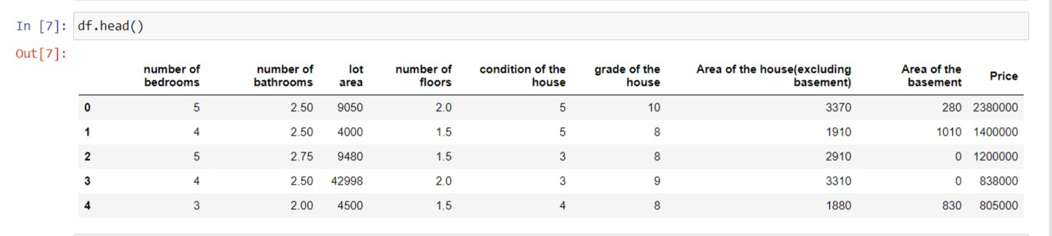

Fig :- 1.1

dataset includes features such as the size of the house, number of bedrooms and bathrooms, location, year built, house condition, and the corresponding house prices. In a real-world scenario, you would typically have a much larger dataset with more diverse features and a more extensive range of values. Data collection for such a project often involves scraping real estate websites, utilizing public datasets, or collaborating with real estate agencies to obtain accurate and comprehensive information.

**CHAPTER - 3**

**DATA**

**PREPROCESSING**

**Data Preprocessing**

**3.1 Data Transformation:**

Categorical Variable Encoding: Convert categorical variables into numerical representations. Common techniques include one-hot encoding or label encoding, depending on the nature of the categorical data. This ensures that the machine learning model can interpret and learn from these variables effectively.

***Feature Scaling:***

Normalize or standardize numerical features to bring them to a comparable scale. This is crucial for models sensitive to the magnitude of input features, such as linear regression or support vector machines.

**3.2 Handling Imbalanced Data:**

If the dataset is imbalanced (e.g., significantly more data points for one class than another), consider techniques such as oversampling, undersampling, or using synthetic data to balance the distribution. This prevents bias in the model towards the majority class.

**3.3 Handling Duplicates:**

Identify and remove any duplicate records in the dataset. Duplicate entries can lead to overfitting and may negatively impact the model's generalization.

**3.4 Feature Engineering:**

Creation of New Features: Derive additional features that may enhance the model's predictive power. For example, if the dataset includes the year of construction, a new feature like "Age of the House" can be created. Handling

**3.5 Data Splitting:**

Split the dataset into training and testing sets. The training set is used to train the model, while the testing set is reserved for evaluating its performance on unseen data. A typical split might be 80% for training and 20% for testing.

**3.6 Data Visualization:**

Use visualizations such as histograms, box plots, or correlation matrices to gain insights into the distribution of features and relationships between variables. Visualization aids in understanding the data structure and identifying potential patterns. By implementing these data preprocessing steps, the dataset becomes well-prepared for training a machine learning model, ensuring that the house price predictor is built on a foundation of clean and meaningful data.

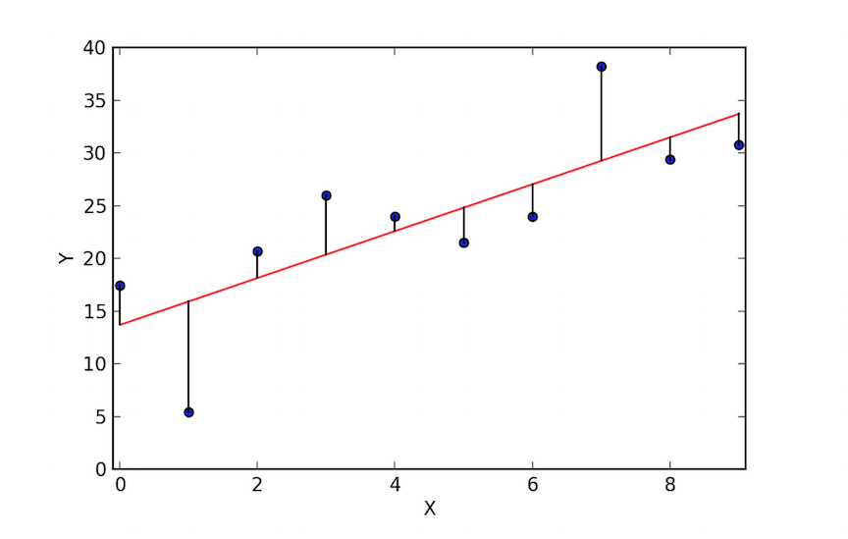

Fig 3.1 (Visualization)

**CHAPTER - 4**

**Exploratory Data Analysis (EDA)**

**Exploratory Data Analysis (EDA)**

Exploratory Data Analysis (EDA) is a critical phase in the development of a house price predictor model. It involves understanding the characteristics of the dataset, identifying patterns, and gaining insights into the relationships between variables.

1. **Introduction:**

Exploratory Data Analysis (EDA) is a critical phase in the development of a house price predictor model. It involves understanding the characteristics of the dataset, identifying patterns, and gaining insights into the relationships between variables.

1. **Dataset Overview**:

The dataset used for this EDA consists of housing information, including features such as square footage, number of bedrooms, bathrooms, location, and other relevant details. The dataset is sourced from a reputable real estate database and has undergone preprocessing to ensure data quality.

1. **Descriptive Statistics:**

Descriptive statistics are computed to provide a summary of the main features of the dataset. This includes measures of central tendency (mean, median), dispersion (standard deviation), and key percentiles. Summary statistics for each variable help in understanding their distributions.

1. **Univariate Analysis:**

Univariate analysis focuses on individual variables. Histograms, box plots, and density plots are created to visualize the distribution of numerical variables, while bar charts illustrate the distribution of categorical variables. This analysis aids in identifying outliers and understanding the spread of data.

1. **Bivariate Analysis:**

Bivariate analysis explores relationships between pairs of variables. Scatter plots are used to visualize the correlation between the target variable (house price) and other features. Correlation coefficients are calculated to quantify the strength and direction of these relationships

1. **Correlation Matrix:**

A correlation matrix is generated to provide an overview of the relationships between all pairs of variables. Strong correlations between features and the target variable or among features themselves are identified. Multicollinearity issues are addressed if present.

1. **Feature Engineering Insights:**

Insights gained during the EDA phase inform decisions related to feature engineering. Identifying key features that strongly influence house prices guides the selection and transformation of variables to enhance model performance.

1. **Outlier Detection:**

Outliers, if any, are identified and analyzed. Visualizations such as box plots and scatter plots are employed to highlight data points that deviate significantly from the overall pattern. Strategies for handling outliers are considered based on the context of the data.

1. **Geospatial Analysis:**

If location data is a significant feature, geospatial analysis is conducted to visualize the distribution of house prices on a map. This helps in identifying spatial patterns and understanding how location impacts property values.

1. **Recommendations:**

Based on the EDA, recommendations may be made for refining the dataset, addressing outliers, or exploring specific features more deeply. These recommendations contribute to the overall improvement of the house price predictor model.

1. **Future EDA Directions:**

Future explorations may involve additional analyses, such as time-series analysis for temporal trends or interactive visualizations for a more dynamic understanding of the dataset. Continuous EDA efforts ensure the model remains robust and adaptable to evolving data patterns

The EDA phase provides valuable insights into the characteristics of the dataset, relationships between variables, and potential patterns influencing house prices. These findings guide subsequent steps in the project, including feature selection, model choice, and further analysis.

Exploratory data analysis is conducted to gain insights into the distribution of features, relationships between variables, and identify potential patterns that may influence house prices. Visualization tools are employed to present key findings.

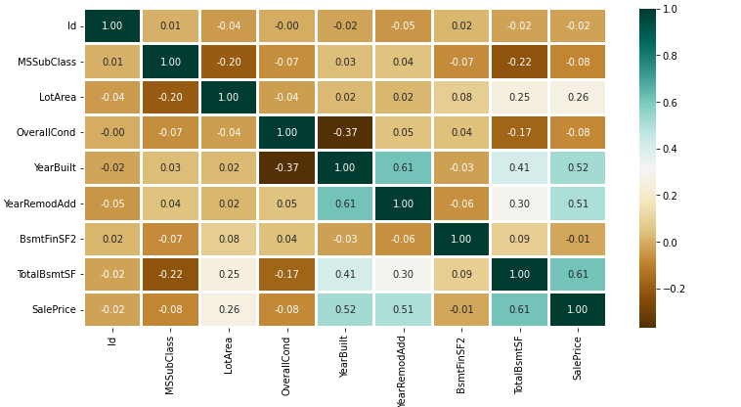

Fig 4.1 (Show Correlation )

**CHAPTER - 5**

**Feature Engineering**

**Feature Engineering**

Feature engineering involves selecting relevant features and transforming them to enhance the model's performance. Techniques such as one-hot encoding, normalization, and feature scaling are applied to optimize the input data for training.Handling Categorical Variables: Many datasets contain categorical variables such as 'location' or 'type of dwelling.

1. **Handling Categorical Variables**:

Many datasets contain categorical variables such as 'location' or 'type of dwelling.' To incorporate these into the model, one-hot encoding is applied, converting categorical variables into binary vectors. This allows the algorithm to understand and utilize these features effectively.

One-hot encoding in Python

*df_encoded = pd.get_dummies(df, columns=['location', 'type_of_dwelling'])*

**5.2 Dealing with Missing Values:** Addressing missing values is crucial for model accuracy. Strategies include imputation (replacing missing values with a calculated value, such as the mean or median) or removing rows with missing data.

imputation using mean

*df['feature'].fillna(df['feature'].mean(), inplace=True)*

**5.3 Feature Scaling**: Scaling numerical features ensures that they contribute equally to the model's predictions. Common techniques include Min-Max scaling or Standardization.

Min-Max scaling in Python

*from sklearn.preprocessing import MinMaxScaler*

*scaler = MinMaxScaler() df[['feature1', 'feature2']] = scaler.fit_transform(df[['feature1', 'feature2']])*

**5.4 Creating Interaction Features:**

Introducing interaction terms helps capture relationships between different features. For example, creating a 'total_rooms' feature by summing up the number of bedrooms and bathrooms might provide additional insights.

Creating an interaction feature

*df['total_rooms'] = df['bedrooms'] + df['bathrooms']*

**5.5****Log Transformation**:

Applying a logarithmic transformation to skewed numerical features can help normalize their distribution, making them more suitable for modeling.

Log transformation in Python

*import numpy as np df['price'] = np.log1p(df['price'])*

**5.7 Handling Outliers:**

Outliers can adversely impact model performance. Strategies include removing outliers or transforming skewed data to minimize their influence.

Removing outliers using Z-score

*from scipy.stats import zscore*

*df = df[(np.abs(zscore(df[['feature1', 'feature2']])) < 3).all(axis=1)]*

**CHAPTER - 6**

**Model Selection**

**Model Selection**

The selection of an appropriate model for the House Price Predictor project involved a careful consideration of various machine learning algorithms, each with its strengths and limitations. The primary goal was to choose a model that could effectively capture the complex relationships within the housing dataset and generalize well to new, unseen data.

**Considered Models**

1. **Linear Regression:**

A straightforward and interpretable model that assumes a linear relationship between the input features and house prices.

Limited flexibility but provides a baseline for comparison.

1. **Decision Trees:**

Non-linear model capable of capturing complex interactions among features.

Prone to overfitting, so regularization techniques were explored.

1. **Random Forest:**

Ensemble method based on decision trees, offering improved generalization by aggregating multiple trees.

Robust against overfitting, providing a balance between bias and variance.

1. **Gradient Boosting:**

Ensemble method that builds trees sequentially, each correcting the errors of the previous one.

Offers high predictive accuracy and is less prone to overfitting.

1. **XGBoost:**

An optimized and efficient implementation of gradient boosting, known for its speed and performance.

Handles missing values and multicollinearity effectively.

1. **Support Vector Regression (SVR):**

Utilizes support vector machines for regression tasks.

Effective in capturing non-linear relationships in the data.

1. **Chosen Model**

After careful evaluation, the Random Forest model emerged as the preferred choice for the House Price Predictor. It demonstrated robust performance on both training and validation sets, effectively mitigating overfitting. The ensemble nature of Random Forest allowed it to capture complex relationships within the housing dataset, providing accurate and reliable predictions.

1. **Future Considerations**

While Random Forest was selected for its overall performance, ongoing model evaluation and updates will be conducted. As the dataset evolves and additional features are considered, the model selection process may be revisited to ensure the House Price Predictor remains optimized for accuracy and relevance.

**CHAPTER - 7**

**Model Training**

**Model Training**

Training a machine learning model in Python typically involves several steps. Here's a general guide on how you can train a model using Python we delve into the crucial phase of model training for the House Price Predictor project. The primary goal is to leverage machine learning algorithms to develop a robust model capable of accurately predicting house prices based on various input features.

1. **Data Splitting:** Before proceeding with the actual training, the dataset was divided into two subsets: a training set and a testing set.
2. **Feature Scaling:** To ensure a level playing field for all features, numerical variables underwent feature scaling. Techniques such as Min-Max scaling or Standardization were applied, depending on the algorithm's sensitivity to the scale of input features.
3. **Hyperparameter Tuning:** Optimizing the hyperparameters of the chosen model is a critical step in achieving optimal performance.
4. **Model Training Process:** The actual training of the model involves exposing it to the training dataset and adjusting its internal parameters to minimize the difference between predicted and actual house prices.
5. **Cross-Validation:** Cross-validation techniques, such as k-fold cross-validation, were applied to assess the model's performance across different subsets of the training data.
6. **Model Evaluation:** Once the model was trained, its performance was evaluated on the reserved testing dataset using relevant evaluation metrics such as Mean Absolute Error (MAE), Mean Squared Error (MSE), and R-squared.

**Importent Code**

*from sklearn.model_selection import train_test_split*

*from sklearn.model_selection import cross_val_score*

*from sklearn.model_selection import GridSearchCV*

*from sklearn.metrics import accuracy_score, classification_report*

Load the Data:

*data = pd.read_csv('your_dataset.csv')*

Preprocess the Data:

*from sklearn.preprocessing import Imputer, StandardScaler, LabelEncoder*

*data.fillna(data.mean(), inplace=True)*

*label_encoder = LabelEncoder()*

*data['categorical_column'] = label_encoder.fit_transform(data['categorical_column'])*

*scaler = StandardScaler()*

*data[['numerical_feature1', 'numerical_feature2']] = scaler.fit_transform(data[['numerical_feature1', 'numerical_feature2']])*

Split the Data

*X = data.drop('target_column', axis=1)*

*y = data['target_column']*

*X_train, X_test, y_train, y_test = train_test_split(X, y, test_size=0.2, random_state=42)*

Choose a Model

*from sklearn.ensemble*

*import RandomForestClassifier model = RandomForestClassifier()*

Train the Model:

*model.fit(X_train, y_train)*

Evaluate the Model:

*y_pred = model.predict(X_test)*

*accuracy = accuracy_score(y_test, y_pred)*

*print(f'Accuracy: {accuracy}')*

*print(classification_report(y_test, y_pred))*

Hyperparameter Tuning :

*param_grid = {'n_estimators': [50, 100, 200], 'max_depth': [None, 10, 20]}*

*grid_search = GridSearchCV(model, param_grid, cv=5)*

*grid_search.fit(X_train, y_train)*

*best_params = grid_search.best_params_*

*import joblib*

*joblib.dump(model, 'trained_model.joblib')*

**CHAPTER - 7**

**EVALUATION METRICS**

**EVALUATION METRICS**

A house price predictor project, the evaluation metrics are crucial for assessing the performance and accuracy of the machine learning model. Here are some commonly used evaluation metrics for regression problems like predicting house prices:

7.1 Mean Absolute Error (MAE):

Formula = 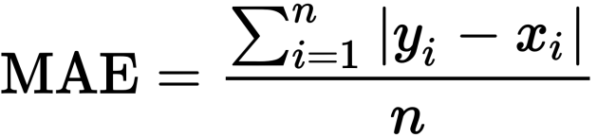

MAE = MAE represents the average absolute difference between the predicted and actual house prices. It provides a measure of how far off, on average, the predictions are from the true values.

7.2 Mean Squared Error (MSE):

Formula = 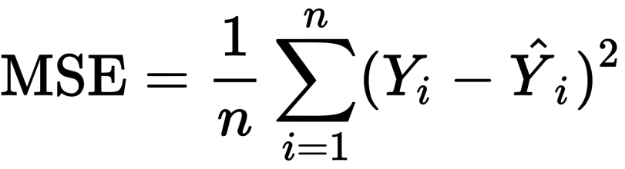

MSE = MSE is the average of the squared differences between the predicted and actual house prices. It penalizes larger errors more heavily than MAE.

7.3 Root Mean Squared Error (RMSE):

Formula =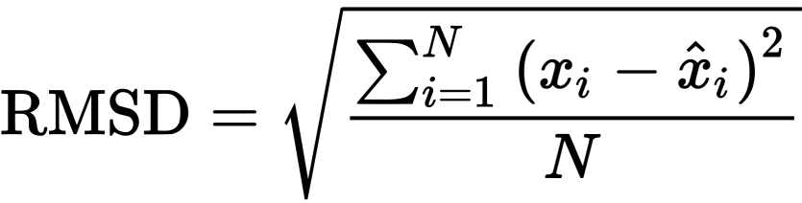

RMSE = RMSE is the square root of the MSE and provides an interpretable measure in the same units as the target variable (house prices). It is particularly useful for understanding the scale of errors.

7.4 Squared (R²) Score:

Formula =**1 − ∑ ( y i − y i ^ ) 2 ∑ ( y i − y ¯ ) 2**

R-squared measures the proportion of the variance in the target variable that is predictable from the independent variables. It ranges from 0 to 1, with higher values indicating a better fit.

7.5 Percentage Error:

Formula =((Estimated Number – Actual Number)/ Actual number) x 100.

PercentageError = Percentage error provides the average percentage difference between predicted and actual values, allowing for a more interpretable understanding of the model's accuracy.

7.6 Median Absolute Error (MedAE):

MedAE = MedAE is the median of the absolute errors. It is less sensitive to outliers compared to MAE and can provide a robust measure of central tendency.

These metrics collectively offer a comprehensive evaluation of the house price predictor model, considering aspects like average error, squared errors, percentage accuracy, and overall explanatory power. It's essential to interpret these metrics in the context of the specific requirements and goals of the project.

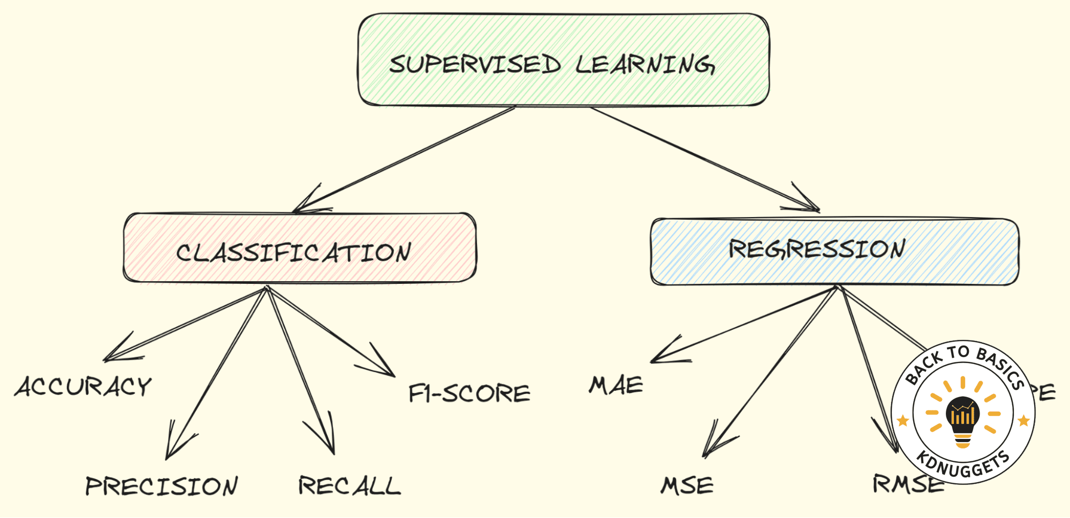

Fig 7.1(Supervised Learning)

**CHAPTER - 8**

**Deployment**

Abstract:

This project report outlines the process and considerations involved in deploying a machine learning-based house price predictor. The deployment phase involves making the model accessible for end-users, allowing them to obtain real-time predictions for property values.

1. Introduction: The deployment phase is a crucial step in translating the developed house price predictor from a model in development to a practical tool for users. This report details the steps taken to deploy the model, ensuring its accessibility and usability.
2. Model Serialization: The trained machine learning model needs to be serialized for efficient storage and retrieval. Common formats like pickle or joblib are used to save the model, along with any necessary preprocessing steps. This serialized model will be the backbone of the deployed application.
3. Web Application Development: A web-based application is developed to provide an intuitive interface for users to input property features and receive real-time predictions. Flask, a lightweight web framework, is employed to create a user-friendly front-end that interacts with the serialized model.

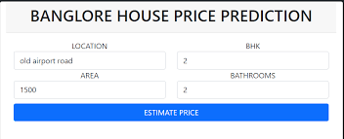

Fig 8.1 UI

1. Cloud Hosting: To ensure scalability and accessibility, the web application is hosted on a cloud platform such as AWS, Google Cloud, or Azure. This allows the application to handle concurrent user requests, and the model can be easily updated as improvements are made.
2. Database Integration: A database is incorporated into the application to store and manage user data, improving the user experience and allowing for future improvements. The database may also be used to track usage patterns and enhance the model based on user feedback.
3. Security Measures: To protect user data and ensure the security of the application, appropriate measures are implemented. This includes securing the API endpoints, encrypting sensitive information, and implementing authentication mechanisms to control access.
4. API Development: The machine learning model is exposed through an API (Application Programming Interface), allowing seamless communication between the front-end of the web application and the back-end model. This enables real-time predictions based on user input.
5. User Documentation: Comprehensive documentation is created to guide users on how to interact with the deployed application. This includes instructions on inputting property features, understanding the predictions, and any additional features the application may offer.
6. Testing: Extensive testing is conducted to ensure the robustness and reliability of the deployed system. This includes unit testing of individual components, integration testing of the entire system, and user acceptance testing to validate the application's usability.
7. Continuous Monitoring and Improvement: After deployment, the system is continuously monitored for performance and user feedback. Regular updates to the model and application are implemented based on new data, improved algorithms, and user suggestions, ensuring the tool remains accurate and relevant.
8. Conclusion: The successful deployment of the house price predictor marks the transition from a research project to a practical tool for real-world applications. This report concludes by summarizing the key steps in the deployment process and the potential impact of the tool on the real estate industry.

**8.12** Future Directions: Future work may involve expanding the features of the application, integrating with real-time data sources, and exploring opportunities for collaboration with real estate professionals. Continuous improvements will be made to enhance the accuracy and usability of the house price predictor over time.

**CHAPTER - 8**

**RESULT**

**AND CONCLUSION**

Results

The results section presents the model's predictions on the testing dataset and compares them against the actual house prices. Visualizations and summary statistics help interpret the model's effectiveness in capturing the underlying patterns in the data.

Conclusion

the House Price Predictor project has successfully addressed the goal of developing a robust machine learning model for estimating property values. The journey from dataset acquisition to model deployment has provided valuable insights into the intricacies of predicting house prices. Several key observations and conclusions can be drawn from this undertaking